PUBLIC ACCESS INDIVIDUAL BLEEDING CONTROL KIT - VACUUM SEALED
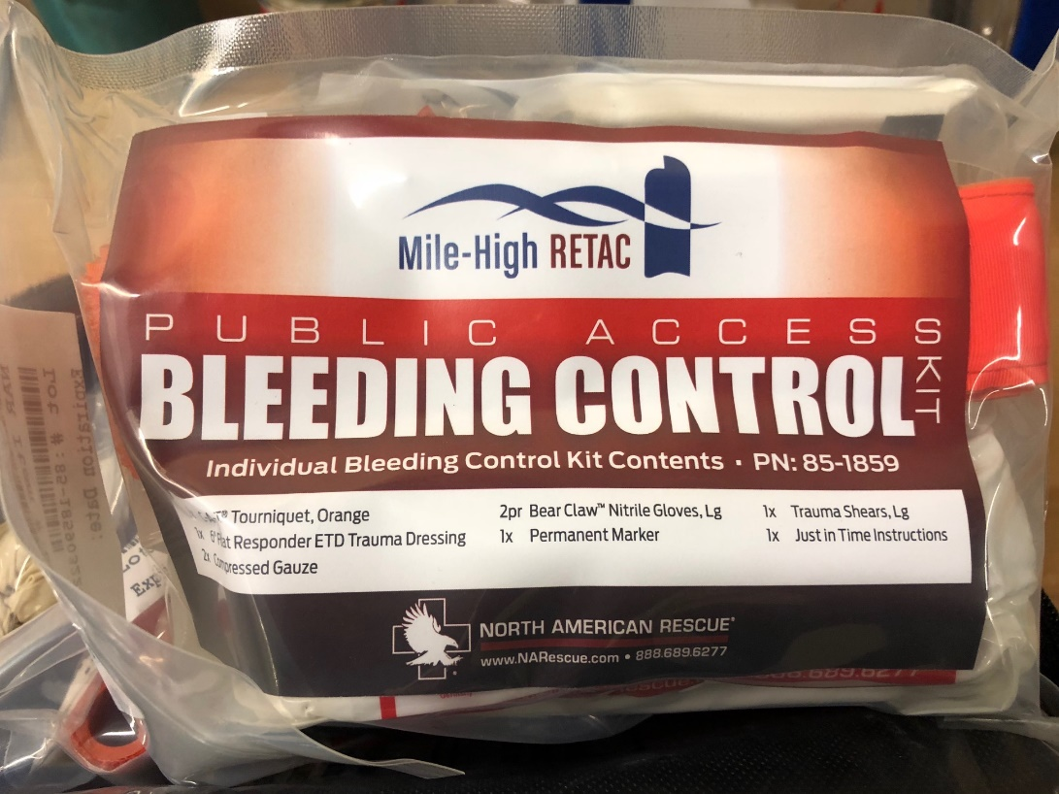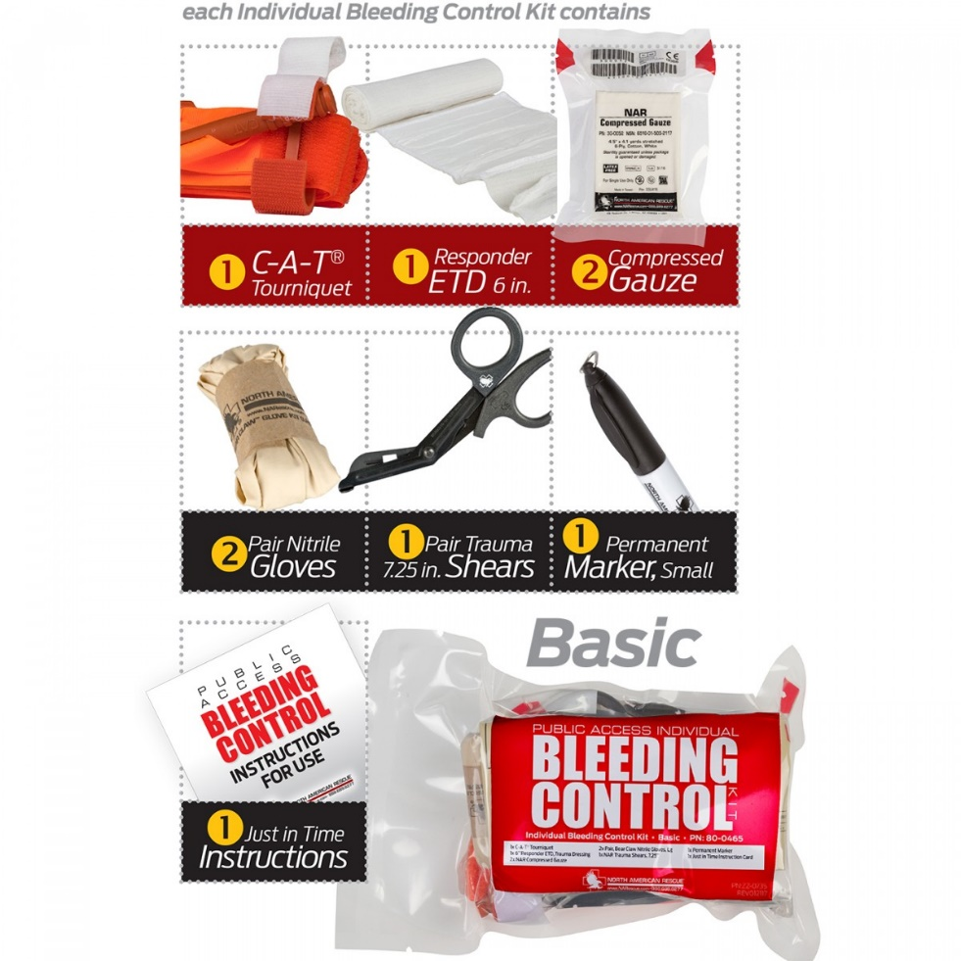

SPECIFICATIONS
- Designed to provide essential equipment that empowers the general public to take action as immediate responders in stopping life threatening bleeding
- Provides intuitive and easy-to-use tools that are proven to help to save lives
- Kits are available in Basic, Intermediate, Advanced and Advanced BCD configurations
- Packaged in a compact, ruggedized vacuum-sealed pouch

BASIC KIT CONTENTS:
- 1 x C-A-T® Tourniquet
- 1 x 6 in. Responder ETD (Emergency Trauma Dressing)
- 2 x NAR Compressed Gauze
- 2 x Pair, Bear Claw Nitrile Gloves, Lg
- 1 x NAR Trauma Shears, 7.25 in.
- 1 x Permanent Marker, Small
- 1 x Just in Time Instruction Card

DIMENSIONS:
- H 7 in. x W 5 in. x D 2.5 in.
- Weight: 15 oz

PUBLIC ACCESS BLEEDING CONTROL 5-PACK - VACUUM SEALED

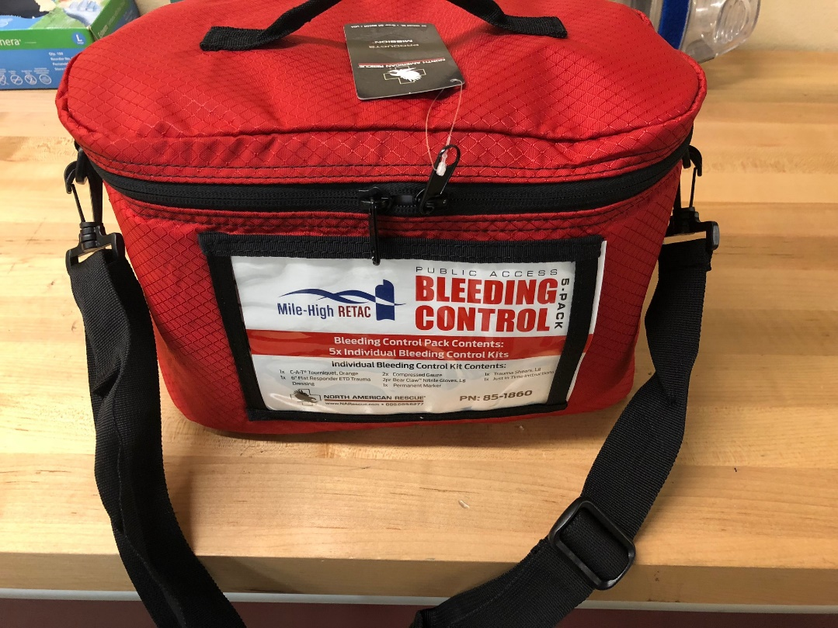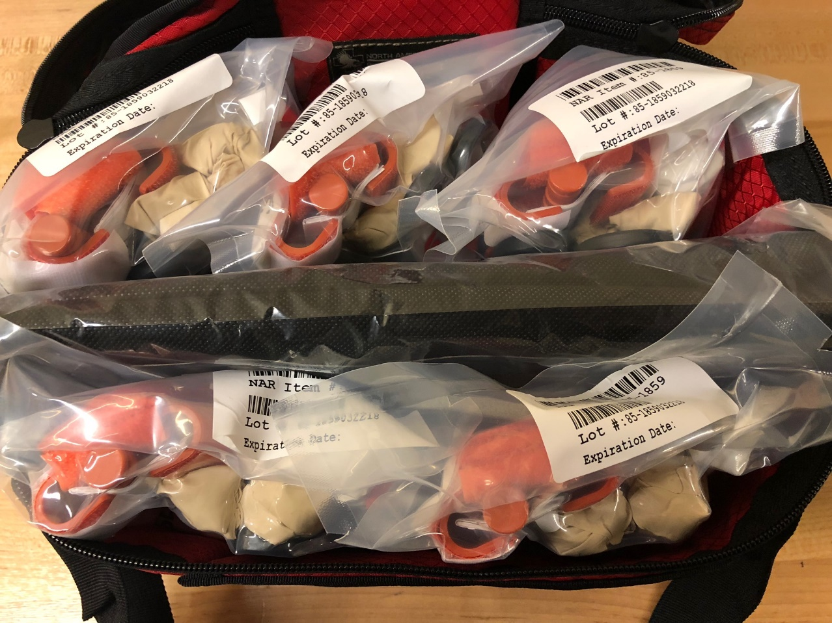
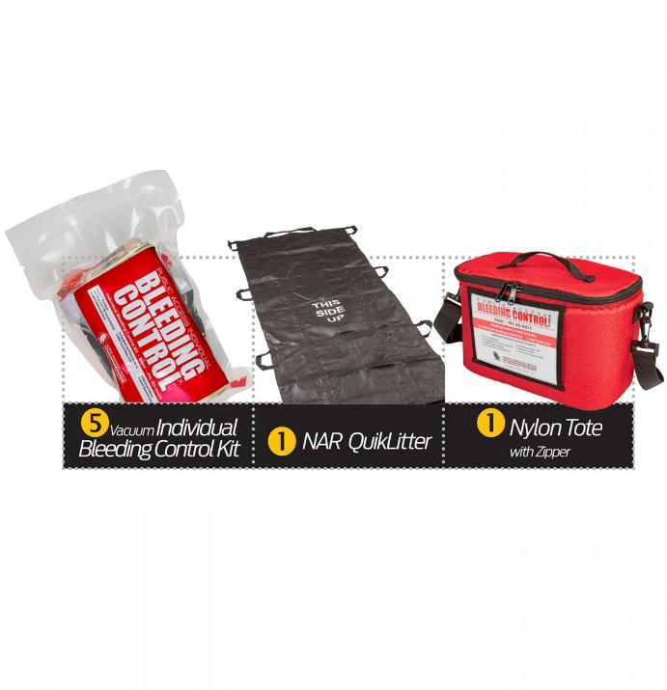

SPECIFICATIONS
- Designed to provide bystanders and initial first responders with quick and easy access to essential medical equipment for stopping life-threatening bleeding
- Includes an easy-to-open zippered tote containing five (5) Vacuum Sealed Individual Bleeding Control Kits packaged in ruggedized vacuum sealed pouches and one (1) NAR QuikLitter™ for moving injured casualties
- Each Basic Individual Bleeding Control Kit contains intuitive and easy-to-use tools proven to help to save lives such as the most effective, easiest to use, fastest to apply C-A-T® Tourniquet
- Available in Basic, Intermediate, Advanced, and Advanced BCD care configurations

BASIC KIT CONTENTS:
- 1 x NAR Red Nylon Zippered Tote
- 1 x NAR QuikLitter
- 5 x Basic Individual Bleeding Control Kits (Vacuum Sealed)
  - 1 x C-A-T® Tourniquet
  - 1 x 6 in. Responder ETD (Emergency Trauma Dressing)
  - 2 x NAR Compressed Gauze
  - 2 x Pair, Bear Claw Nitrile Gloves, Lg
  - 1 x NAR Trauma Shears, 7.25 in.
  - 1 x Permanent Marker, Small
  - 1 x Just in Time Instruction Card

DIMENSIONS:

Packaged Tote:
- H 7.5 in. x W 13 in. x D 8 in.
- Weight: 5.7 lb

Individual Bleeding Control Kits:
- H 7 in. x W 5 in. x D 2.5 in.
- Weight: 11.7 oz

