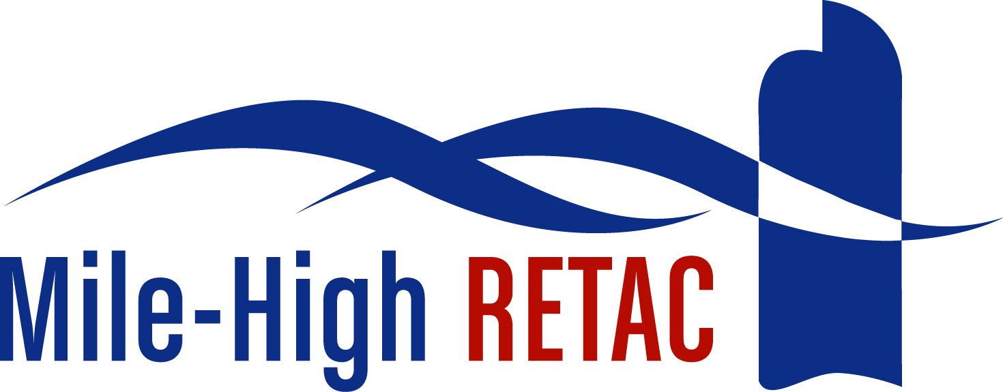

Mile-High Regional Emergency Medical and Trauma Advisory Council (MHRETAC)

Ambulance Inspection Reimbursement
Grant Guideline and Application

January 2016

Dear Applicant:

The Mile-High RETAC is committed to supporting EMS agencies within the six cities and counties (herein referred to as counties) of the MHRETAC. The MHRETAC includes Denver, Broomfield, Elbert, Douglas, Arapahoe and Adams counties. To help accomplish this, the MHRETAC Council has instituted a grant process to reimburse EMS agencies for a portion of the ambulance inspection fees. The MHRETAC began paying for the ambulance inspections for the six counties in 2000.

The Multi-County Ambulance Licensing Committee consists of Broomfield, Elbert, Douglas, Arapahoe, Adams and Jefferson County. Denver pulled out of this committee January of 2010. Through the efforts of this Multi-County Ambulance Licensing Committee, there are now standardized applications, inspections, complaint forms, ordinances and reciprocity. All documents are in compliance with the State’s Ground Ambulance Rules that were adopted on April 7, 2005 and became effective November 1, 2006.

If an EMS agency has a base station in Denver, it must obtain a license to conduct business in Denver in addition to the ambulance licensing in one of the counties that are included in the Multi-County Ambulance Licensing Committee. Agencies may provide mutual aid/overflow into Denver without obtaining a license in Denver. Mutual aid/Overflow refers to those agreements between departments and agencies that allow for the occasional assistance with emergency response calls that the primary agency or department cannot immediately respond to or in situations that require extra assistance. These agreements are designed to assist the primary agency not to operate in lieu of the agency.

Each agency must pay Jefferson County directly for administering the ambulance inspection program for these six counties and request the funds from the MHRETAC with the proper documentation. This grant may be applied for on a yearly basis.

Ambulance Inspection Grant Guidelines

- Any EMS agency within the MHRETAC may apply for these funds.
- The funds can only be used for ambulance inspections.
- The annual Agency Profile must be on file with the state to receive these funds. These profiles are due each March 1st.
- Grants will be reviewed by the MHRETAC Grants Committee and then forward the information to the MHRETAC for final determination. The Grants Committee is held at 10:30 prior to each MHRETAC meeting.
- Agencies will be notified following the final approval by the MHRETAC.
- The MHRETAC meets on the odd months starting in January. The meetings are held from 11-1pm at the Rita Bass Trauma and EMS Education Institute, located at 190 W. 6th Ave.
- All follow-up documents, inspection forms, receipts demonstrating that the funds were used for ambulance inspections and other related documents must be submitted to the MHRETAC Executive Director within 30 days of the ambulance inspections and prior to requesting these funds.
- MHRETAC may withhold and/or recover grant funds in case such funds are, or appear to be, misused.
- There is no appeal process if denied.
- Agencies may apply each year with submission of a new application.
- A scoring process will be conducted to determine each agencies eligibility for the grant.
- Grant requests must be submitted to the MHRETAC Executive Director via e-mail or send one hard copy with signatures to the MHRETAC Executive Director at the address below:

Shirley Terry
MHRETAC Executive Director
2352 South Juniper Way
Lakewood, Colorado 80228
Office-303.722.6734
Cell-303.919.0719
shirleyterry@comcast.net

Mile-High Regional Emergency Medical and Trauma Advisory Council (MHRETAC)

Ambulance Inspection
Grant Application

Date:

Agency Name:

Agency Address:
Street
City
Zip Code

County:

Agency Phone:

Contact Name:

Contact Title:

Contact Phone Numbers:
Main Office:
Direct Line:
Cell:
E-mail:
Total Number of Ambulances Inspected:

Date of Inspection:

Total Amount Requested ($60 per ambulance):

Is your agency contributing to the ambulance inspection fees?
Yes, amount:
No

Please attach the following:
Copy of the paid ambulance inspection fee
Proof of ambulance inspections- (can be a summary)
Date of the agency profile update

Please check the appropriate box in each section:

Type of Agency:
Volunteer

*Majority Volunteer, Some Career

*Majority Career, Some Volunteer

Career

*the majority of manpower provided on 51% of calls

Revenue Sources:
Fundraisers/Donations Only

*Majority Fundraisers/Donations, Some taxes or fees
*Majority taxes or fees, some fundraisers/donations
Supported only by taxes and fees

*the majority of the ambulance budget covering 51% of costs

EMS Transport Volume:
Fewer than 500 Transports per year

500-1500 Transports per year

1500-3000 Transports per year

> than 3000 Transports per year

What is the overall condition of the finances for this agency at this time? (Is the budget in the black or red?) Please add any additional comments relating to finances that you feel would be helpful for the committee.

Agreement

By signing this section, this agency has agreed that any ambulance inspection funding from the Mile-High RETAC will be applied towards the paid ambulance inspections. All requested documents are attached.

Signature: _____________________________________

Title: _________________________________________

Date: ______________________

